Piezoelectric Pressure Sensing Shoe Insole

Team 47: Gerald Kozel and Alan Lee

ECE 445 Project Proposal

TA: Kyle Michal

**1. Introduction**

**1.1 Objective**

Over half of limb amputations (about 67 percent) in the United States are attributable to diabetes and related complications. The majority of limb amputations are performed on the lower extremities. Diabetic neuropathy and subsequent damage to sensory nerves in the feet contribute greatly to deformities and ulcers, thereby increasing the risk for amputations if left untreated. This scenario is sadly all too common for diabetic individuals.

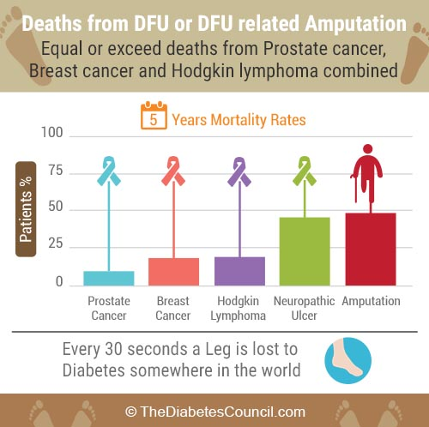

Figure 1 - Statistics on deaths from diabetes related amputation [4]

These statistics are alarming when compared with the CDC estimate that 30.3 million Americans currently have diabetes. From this data, we can draw that a cornerstone of diabetes self-management and education is foot care and continuous monitoring of patient foot physiologic symptoms. In addition, the diabetes medical devices market size worth will be $35.5 billion by 2024 with a CAGR 7.0% [5]. This makes a sizable market that is prime for disruption as there has not been much innovation with regards to medical care for those with diabetes. Medical devices in the area for the most part are still running on antiquated technology making pain points abundant for the population using them.

To address this, our goal is to create a device that can provide actionable health information to a health care provider without interfering with daily life. Specifically, we decided to focus on gathering quantitative foot pressure distribution data in a way that is clinically useful for evaluating various foot or posture pathologies. This data can be invaluable for avoiding extremity amputation for diabetics. These insights will bring early detection and preventative measures to patients at high risk for such procedures and notify clinical professionals of patient statuses throughout monitoring their conditions.

We will achieve this by building a piezoelectric powered insole which will be embedded with pressure sensors that are connected to a microcontroller. This microcontroller communicates via Bluetooth with a phone application which processes the data into a format that displays the user’s foot pressure distribution over a period of time. This can be a disruptive solution in monitoring whether neuropathic ulcers appear on the foot which is the primary reason for a foot amputation.

**1.2 Background**

Today, pressure mapping is mostly limited to lab analysis, kiosks, and existing commercial insoles. Both the kiosks and other insoles such as DigitSole ([www.digitsole.com](http://www.digitsole.com)) have limited use cases. For example, Digitsole provides pressure distribution data but does not facilitate the clinical application of said data. Rather, these focus on selling orthopedic insoles or providing runners with feedback in their techniques. TekScan, a producer of foot pressure sensing devices, offers a similar insole device called F-Scan. This solution is quoted at a price of $6,995 plus $35 per insole [1]. This is much more expensive than our planned solution, allowing us to sell the device to a much larger base of consumers at a reasonable price.

**1.3 High Level Requirements**

1. Shoes stream dynamic foot pressure data from 0 to 120 kPa per sensor in a 50 - 60 KB data set once per hour of operation and display foot location mappings on a mobile app. (supplemental equations 2.3.1a and 2.3.1b)
2. Insole should be able to run from full charge for at least 8 hours in normal operation (without considering piezoelectric charging capabilities).
3. Piezoelectrics should offer energy savings of a 2-5% increase in original battery life.

**2. Design**

**2.1 Block Diagram & Physical Design** 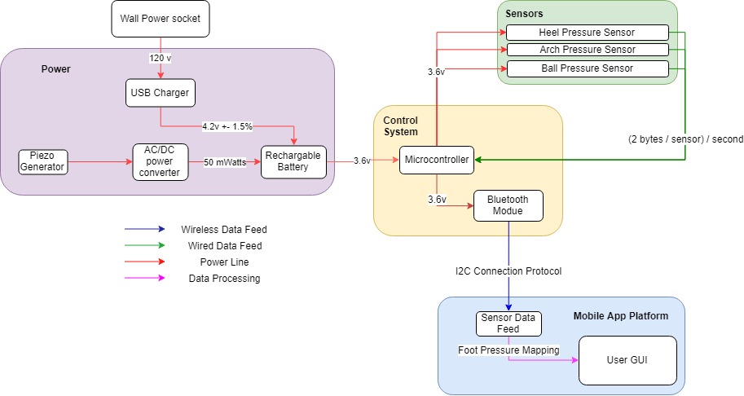

Figure 2 - Block diagram of design of subsystems (one shoe)

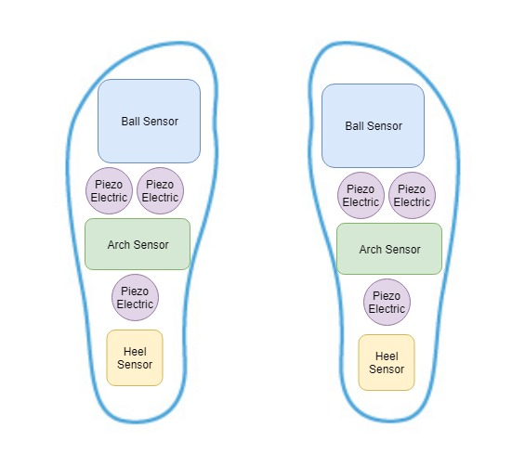

Figure 3 - Physical layout of insole aerial view

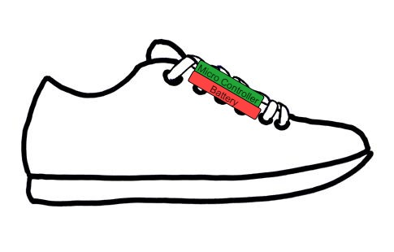

Figure 4 - Physical layout of shoe side view

**2.2 Functional Overview, Requirements and Verifications**

**2.2.1 Power Supply**

The first module is power, which includes our lithium ion battery and piezoelectric sensors. These connect to each other to enable charging capabilities as the user walks. This module primarily provides power to our sensor block where three pressure sensors are aligned on the sole, arch, and ball of the foot.

*Piezoelectric Generators*

These Sensors will provide supplemental power to charge the battery in use from the user stepping on them. The primary purpose of these sensors is to satisfy our battery life requirement.

|  |  |
| --- | --- |
| Requirement | Verification |
| * Within 1 hour of walking, must provide a mean charging rate of 50 mW | 1. Discharge battery to cut off voltage of 3.3V 2. Operate the shoe with piezo generators for 1 hours 3. Measure the battery voltage with a multimeter after 1 hour 4. Connect 10 ohm resistor to the battery 5. Measure the current through the load using a multimeter. 6. Ensure the calculation of power from the voltage and current readings result to at least 50 mWatts as average |

*AC/DC Power Converter*

This handles both typical charging operation along with integrating the energy generated from the piezoelectric sensor. The charging capabilities will ensure we can get sufficient energy savings from our piezoelectrics and power our insole.

|  |  |
| --- | --- |
| Requirement | Verification |
| * Must convert AC to DC (bridge rectifier) to store energy generated by the piezos | 1. Measure the current with a multimeter and ensure that the signal is of AC type 2. Walk on the insole with the piezos and measure power output over 1 hour. 3. Verify that the energy output of the piezo sourced charging provided 2-5% extension on total battery life within one hour. |

*USB Power Converter*

The purpose of the USB Power Converter module is to step voltage down from a wall socket to a USB which can be used in a commercial lithium ion charging circuit to charge the battery. This is the primary source of charge for our battery as the piezos will not generate enough power to sustain the battery for 8 hours.

|  |  |
| --- | --- |
| Requirement | Verification |
| * Must step down 120V wall output to USB | 1. Visually inspect the datasheet associated with the wall to USB adapter. 2. Ensure the device works with 120V wall outputs to step down to a 5V USB. |
| * USB charger must charge the battery at a rate of 5 +/- 0.2 watts (5V at 1A) and to a level of 3.6V | 1. Discharge the battery to cutoff voltage (3.3V) 2. Use a multimeter to measure both voltage and current draw from the charger. 3. Calculate energy transfer by multiplying measured voltage and current and compare to expected rate. |
| * Battery must remain between 10 - 40 degrees Celsius during charging. | 1. Throughout the charging cycle, utilize an IR thermometer to measure temperature. Try this for a range of ambient temperatures and for a full 8 hour day. |

*Rechargeable Li-ion Battery*

Our battery will operate at 3.3-4.2V and will power the majority of our design. The chosen capacity and voltage will allow the device to function for the specified 8 hours in our high level requirement.

|  |  |
| --- | --- |
| Requirement | Verification |
| * Must store 2000 mAh of charge | 1. Connect the fully charged lithium ion battery to a test circuit 2. Set up the test circuit to take a constant current draw of 250mA from the battery for 8 hours 3. Utilize a voltmeter to make sure voltage remains above 3.3 volts. |

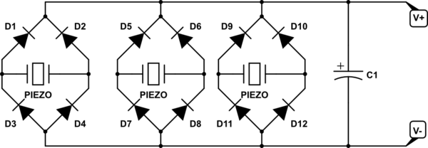

Figure 5 - Example diagram for our piezoelectrics and their associated capabilities.

**2.2.2 Sensors**

*Heel, Arch, and Ball Pressure Sensors*

These pressure sensors will dynamically feed its foot pressure data to the mobile app at various parts of the foot. This allows us to measure pressure to the amount required by our high level design. Our pressure threshold of 120 kPa is quantified in supplemental calculation 6.1.

|  |  |
| --- | --- |
| Requirement | Verification |
| * Must be able to sense pressure up to 120 kPa (double the applicable weight) | 1. Add increasing amounts of pressure to each sensor individually and observe the output voltage from the voltage divider. 2. FSR should not be saturated at 120 kPa, check that voltage still changes with pressures a little over and under 120 kPa. |

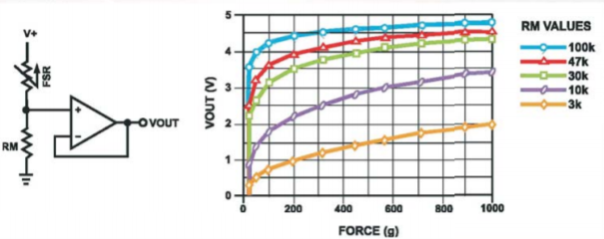

Figure 6 - Voltage divider circuit and response. For our application RM=1kΩ and V+ = 3.6V. [6]

**2.2.3 Control System**

Both the sensor block and the power block connect to our control system block, which includes a microcontroller and Bluetooth transceiver/antenna for receiving and sending the data to the app.

*Microcontroller*

The microcontroller handles the data from the three pressure sensor feeds. It will intake these inputs and utilize the Bluetooth transceiver to stream the data to the Mobile App Platform.

|  |  |
| --- | --- |
| Requirement | Verification |
| * Must be powered by a 1.8v - 5.25v +- 15%, 19mA +-10mA power supply for 8 hours | 1. Verify figures on data sheet 2. Must see the microcontroller turn on while measuring voltage input is within expected range 3. Let the device run for 8 hours. Check back to ensure there is still power at this point by checking battery voltage. |
| * Must have sensor data input ports and support the I2C protocol for sending data via Bluetooth | 1. Verify the microcontroller has sensor inputs on the datasheet/website. 2. Step through the communication protocol with another device to send a test packet. Verify it is sent and received on both sides. |

*Bluetooth Transceiver*

The transceiver will be the component that allows the microcontroller to communicate with the mobile app platform. The Bluetooth transceiver is chosen with specs that meet our streaming requirement.

|  |  |
| --- | --- |
| Requirement | Verification |
| * Must be compatible with our microcontroller and the I2C protocol | 1. Verify transceiver has I2C capability in datasheet |
| * Must operate on 2.4GHz bandwidth | 1. Verify the transceiver operates on Bluetooth’s standard bandwidth of 2.4GHz on the datasheet |
| * Must operate on a range of 30 meters | 1. Separate device and insole at the maximum 30 meters. 2. Verify communication is stable by pressing the active collection button and viewing the pressure map. |
| * Must transfer data losslessly | 1. Verify that data transfer of pressure sensors is lossless through visual inspection of data set. |

**2.2.4 Mobile App Platform**

The mobile app platform will serve as the main user interface for the patient/user. It will be comprised of a mobile app screen that will capture the sensor feeds and visualize it into an aggregated pressure map of the user’s foot.  This solves high level requirement 1.

|  |  |
| --- | --- |
| Requirement | Verification |
| * Must be able to connect to the Bluetooth adapter on the insole | 1. Call startDiscovery() within the app and then use getAddress() to receive the MAC address associated with the discovered device. 2. Initiate the connection by calling connect and check to make sure it does not throw a 3. Wait for a push notification popping up indicating that the connection is successful. |
| * Must have a foot display for how pressure distribution | 1. Verify app has foot pressure UI that is displays data taken from the insole after a gather data button is pressed. |
| * Must display accurate pressure sensor data | 1. Check for malformed data by applying pressure on each sensor individually and inspecting the display in the app. Pressure should appear in the corresponding areas with a level that matches the weight. |
| * Must have Android OS compatibility | 1. Verify app runs on an Android device. |

**2.3 Supporting Materials**

**2.3.1 Calculations**

**2.3.1a Threshold Pressure**

We will use the assumption of a 120kg person with 0.01m^2 foot surface area (size 9).

**2.3.1b Necessary Onboard Memory**

**2.3.1c Piezo Power Charging output**

**2.3.2 Software Flowcharts and GUI**

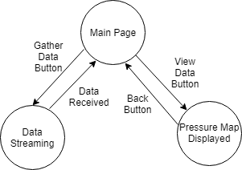

Figure 7 - App flowchart

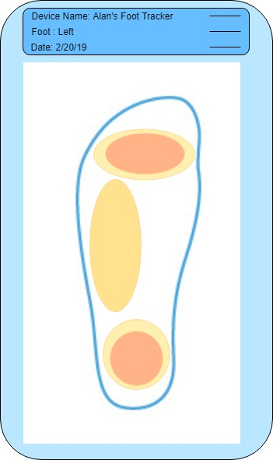

Figure 8 - App GUI

**2.4 Risk Analysis**

The Control System will pose a significant challenge in the successful completion of this project. We must ensure that the microcontroller is compatible with the Bluetooth transceiver. The Bluetooth transceiver must have an adequate bandwidth and latency for a lossless stream of data from the connectors. It must also communicate to the mobile device which will be separated by a few feet (length of a person). The wiring of the microcontroller will also pose a challenge. Design for how it will be wired for power and sensor feed will be crucial to not obstruct the users walking while still having reliable wired connections.

Another module with a high amount of risk is our sole construction. Based on the way we set up the sensors it’s possible for wires and components to become loose as the entire rig is in consistent contact with the weight of a walking person. Additionally, our sensors will need calibration in order to receive usable data as

The power subsystem also poses a challenge as creating a schematic which harvest the piezo generators in a sufficient manner to reach a significant power savings will need consideration. Optimizing piezo location placement and having a realistic expectation of how much the piezo generators may save is crucial for the success of the device. As pressure movement will dictate how much energy is generated, there are many factors in play on how much power savings will be achieved.

Our mobile app is the lowest risk of our modules. As long as our data and our communication protocol is sound developing the app to do some simple calculations on that data is relatively straightforward. We anticipate the least amount of problems working on this module of our design after putting sufficient work into our other modules.

**2.5. Tolerance Analysis**

A factor is to consider heavily in the design of this product will be the users foot physiology. The most common archetypes that have been taken into consideration when designing this product are low arch / flat feet, medium arch, and high arch. The users foot physiology in combination with their walking style will impact what level of power can be supplied by the piezo generators as well as the pressure distribution and the necessary pascal tolerances for the sensors. From numerous health institutes, it has been estimated approximately 20% of the population has low arches, 60% of the population has medium arches, and 20% of the population has high arches. Low arch, medium arch, and high arch foot pressure can be visualized below.

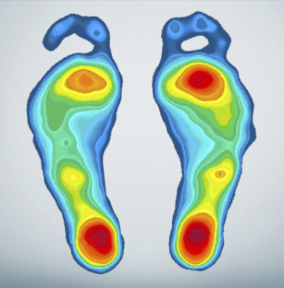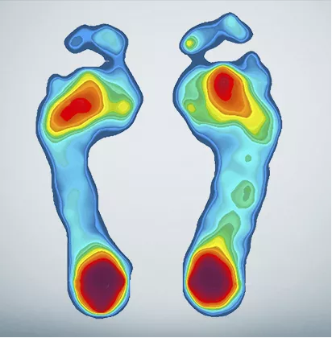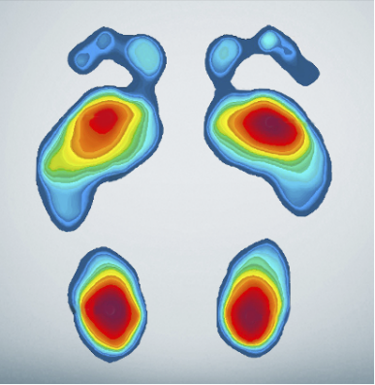

Figure 9 - foot pressure distribution by arch [7]

An important tolerance we must maintain when looking at the usage of the product is the pressure sensors range so that users can have an accurate depiction of all parts in contact with the insole. The upper bound of pressure for pressure sensors that has been defined for this device is 120 kPas. This comes from having the target upper bound of 120 kg or 265 lbs. as a user’s heaviest weight. Such a high weight was chosen as the upper limit because our target audience is diabetic which typically comes as an onset after being overweight or obese. While in use, we can assume that user exerts their full body weight on both feet. For example, when standing, a user will exert 120 kPa on both feet. For one foot, they will only exert 60 kPa.  Then by drilling down the granularity of the pressure sensors, depending on arch type, users will distribute up to 50% of one foot’s pressure on the heel and the other 50% of pressure on the ball of the foot if high arched. If flat footed, the user will put approximately 25% of their weight on the arch area. This requires the pressure sensors of both front and back of the foot tolerate up to 30k Pascals (50%) while standing and the arch pressure sensor tolerate from 0 to 15k Pascals (25%).

* Heel Sensor Total Pressure standing tolerance 30k pascals = 120k Pascals / 2(per foot) * 50% (foot location max pressure distribution for high arch)
* Ball Sensor Total Pressure standing tolerance 30k pascals= 120k Pascals / 2(per foot) * 50% (foot location max pressure distribution for high arch)
* Arch Sensor Total Pressure standing tolerance 15k pascals= 120k Pascals / 2(per foot) * 25% (foot location max pressure distribution for flat foot)

The other case to consider is when walking users typically exert double their normal standing pressure on one foot. This makes it necessary for each insole tolerance to rise to 120k tolerance from the previous standing 60k pascal tolerance.

* Heel Sensor Total Pressure standing tolerance 60k pascals= 120k Pascals * 50% (foot location max pressure distribution for high arch)
* Ball Sensor Total Pressure standing tolerance 60k pascals= 120k Pascals * 50% (foot location max pressure distribution for high arch)
* Arch Sensor Total Pressure standing tolerance 30k pascals= 120k Pascals  * 25% (foot location max pressure distribution for flat foot)

After converting Pascals to force, we can use the equation below along with the chart from the pressure sensor datasheet to calculate what a given voltage reading for pressure will be depending on arch type. This is invaluable for determining whether the device will operate correctly given an arbitrary pressure exertion from a user and to see if the pressure sensors saturation point is high enough for the device to not limit its audience to a specific weight range.

https://lh5.googleusercontent.com/PYM2E14H2wRJZeEpJTujXXHVNKVoa1Gw_d4X2s2aidMkyPwDcew273OO1OiK4tVCA9AaB7Zv0xL1rIkrB31NoN6NqkOgWYRObwtev9iLnWEB7xsNG2DaYZtREczVXk79pWf7ho2p

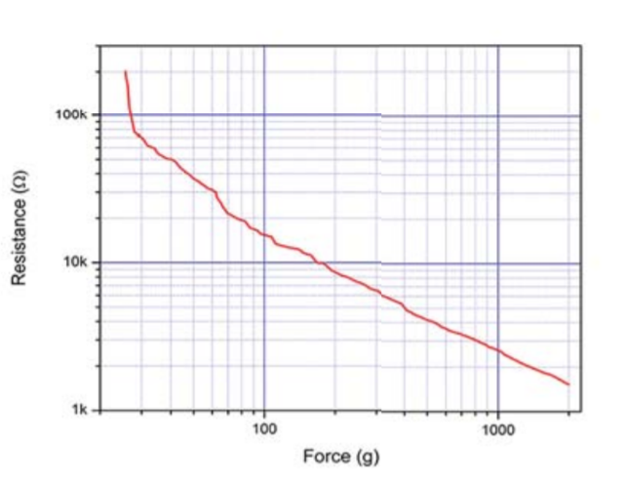

Figure 10 - Resistance v Force response for an FSR up to 1000g [6]

**3. Cost and schedule**

**3.1 Cost Analysis**

**3.1.1 Labor**

|  |  |  |  |
| --- | --- | --- | --- |
| **Name** | **Rate per Hour** | **Hours** | **Total Cost * 2** |
| Alan Lee | $40 | 14 hr. /wk. * 12 wk. = 168 hrs. | **$13,440** |
| Gerald Kozel | $40 | 14 hr. /wk. * 12 wk. = 168 hrs. | **$13,440** |
| **TOTAL** | | | **$26,880** |

**3.1.2 Parts**

|  |  |  |  |
| --- | --- | --- | --- |
| **Part** | **Distributor and Number** | **Amount** | **Cost** |
| Piezoelectric Sensors | Multicomp; ABT-441-RC | 6 | **$6.78** |
| Lithium Ion Battery | ShenZhen; ICR18650 | 2 | **$25.00** |
| Microcontroller | Silicon Labs; C8051F50x | 2 | **$11.24** |
| Wireless Bluetooth Transceiver | Microchip; RN4870/71 | 2 | **$14.46** |
| Pressure Sensors | Interlink; FSR-406 | 6 | **$53.70** |
| Resistors, capacitors, op-amps, diodes | Digikey | ~30 in all | **$10.00** |
| Foam Insole | Target; Up&Up | 1 (pair) | **$0.99** |
| Lithium Ion Battery Charger | NanJing Top Power; TP4056 | 1 | **$5.60** |
| **TOTAL** | | | **$122.77** |

**3.1.3** Grand total for our project comes out to be $27002.77 with both parts and labor.

**3.2. Schedule**

|  |  |  |
| --- | --- | --- |
| Date | Gerald | Alan |
| 2/23 | Finalize design document. Order parts to test/prototype. | Finalize design document. |
| 3/2 | Test and verify piezoelectrics and charging capabilities. | Test and verify battery and pressure sensors. |
| 3/9 | Create PCB design. Attach sensors to insole and check wiring. | Order PCB. Test and verify control system. |
| 3/16 | Integrate PCB with other modules. Build android app. | Put together battery/microcontroller rig. |
| 3/23 | Spring break. Finish app and order any additional parts. | |
| 3/30 | Test and verify complete hardware design. Reorder PCB if needed. | Begin testing connection between app and Bluetooth transceiver. |
| 4/6 | Verify Bluetooth connection and integrity of data. | Adjust mobile app to receive data through Bluetooth. |
| 4/13 | Prep for demo. Test in field to get data to show for the demo/presentation. | |
| 4/20 | Final demo. | |
| 4/27 | Final presentation. | |

**4. Discussion of Ethics & Safety**

As with many engineering projects, there are a few possible safety hazards involved. Our lithium-ion battery rechargeable battery which powers the device has a possibility to explode. This usually occurs in the case of a short circuit, where all of the energy within the battery is released at once. Short circuits like this can happen when the plastic separator fails between the anode and cathode, allowing them to physically touch [2]. Over-charging and high temperatures must be avoided at all costs and must be tested for while building the charging module of our project. Other than proper testing we would ensure to get our batteries from a reputable supplier with a good track record for quality product. Additionally, we would provide proper insulation in the insole so that the battery is not subjected to extreme cold or heat.

Our project gathers and processes potential Protected Health Information (PHI), which is requires us to ensure confidentiality, integrity, and availability of said data [3]. We would not include diagnosis within the app to avoid violating #3 in the IEEE code of ethics by potentially misdiagnosing a user. Primarily the data would be in the hands of a medical doctor who could utilize it accurately. It’s important to note that this product will not be doing any analysis on the data, instead giving a professional means to conduct that analysis themselves.

**5. Citations and References**

[1] Open Lab, ‘Wearable Weight Sensing and Feedback Device’. [Online]. Available: <http://www.openlab.psu.edu/wp-content/uploads/2014/04/Garneau_Wearable_Weight_Sensing_and_Feedback.pdf>. [Accessed: 6-Feb-2019].

[2] Battery University, ‘Safety Concerns with Li-ion Battery’. [Online]. Available: <https://batteryuniversity.com/learn/article/safety_concerns_with_li_ion>. [Accessed 6-Feb-2019].

[3] HIPAA Journal, ‘What is Protected Health Information?’. [Online]. Available: <https://www.hipaajournal.com/what-is-protected-health-information/>. [Accessed: 6-Feb-2019].

[4] The Diabetes Council, ‘diabetes-and-amputation-everything-you-need-to-know-to-avoid-amputation’. [Online]. Available: <https://www.thediabetescouncil.com/diabetes-and-amputation-everything-you-need-to-know-to-avoid-amputation/>. [Accessed: 2/18/2019].

[5] Grand View Research, ‘global-diabetes-devices-market’. [Online]. Available:

<https://www.grandviewresearch.com/press-release/global-diabetes-devices-market>.

[Accessed: 2/20/2019].

[6] Adafruit, ‘FSR 400 Series Data Sheet’. [Online]. Available: <https://cdn-shop.adafruit.com/datasheets/FSR400Series_PD.pdf>. [Accessed 2/20/2019].

[7] Foot.com, ‘Arch Types’. [Online]. Available: <https://www.foot.com/arch-types/> .

[Accessed 2/20/2019]

[8] NCBI, ‘A Shoe-Embedded Piezoelectric Energy Harvester for Wearable Sensors’. [Online]. Availible: <https://www.ncbi.nlm.nih.gov/pmc/articles/PMC4168512/> . [Accessed 2/20/2019]